OBSERVER REGISTRATION FORM

Asian Conference on Institutional and Action Research (ACIAR 2017)
May 25-27, 2017
N Hotel, Cagayan de Oro City, Philippines
Theme: “Research Solutions to School Problems”
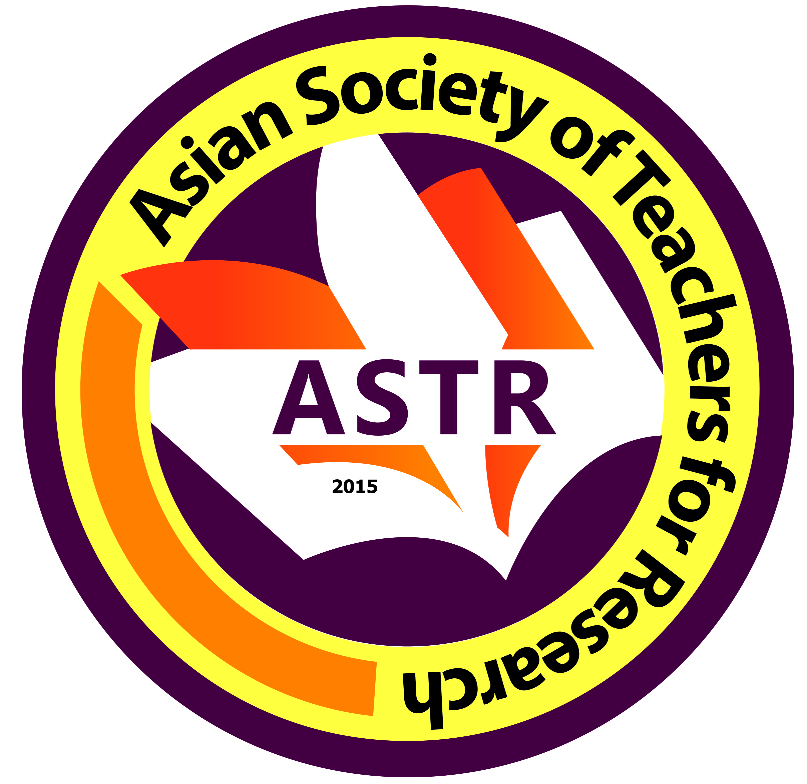
Date Filed:

First Name:
Middle Name:
Last Name:
Email Address:
Mobile No. (begin with country code):
ORCID No (register at www.orcid.org):
Field(s) of Expertise:
Organization/School/University/Affiliation:
Address of Organization/School/University/Affiliation:

*Please attached a formal ID Photo and updated Curriculum Vitae

